Can Kyeema withdraw my support?

Yes, under certain circumstances Kyeema can withdraw my support

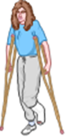

If staff are in danger due to behaviours of concern (violence)

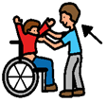If Kyeema is unable to find the right staff to support your needs (but we will certainly try)

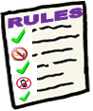

If you are engaged in illegal activities that might create a risk for Kyeema staff

j0432153j0432153

Kyeema will not withdraw support just because you have made a choice that we do not think is safe for you

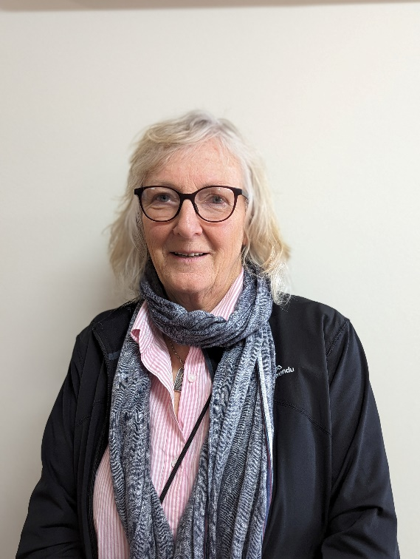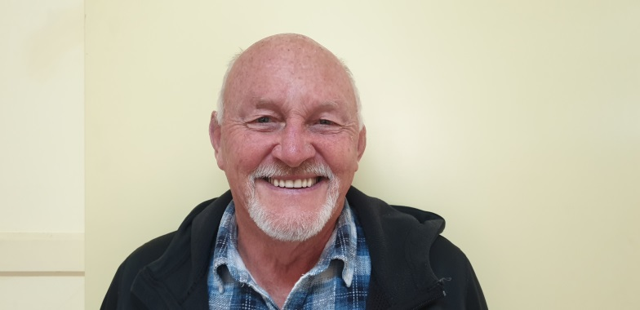You may talk with the NDIS Commission and/or an independent advocate about any decision we make.

NDIS Commission

Southwest Advocacy Association Inc.

Ph. 0355614584

Jen Merrett Iain McDonald

0409 046 250 (03) 5523 1662